10 July 2018.
Melisa Pizzolato

Emily Longworth Award
Final Report
Introduction

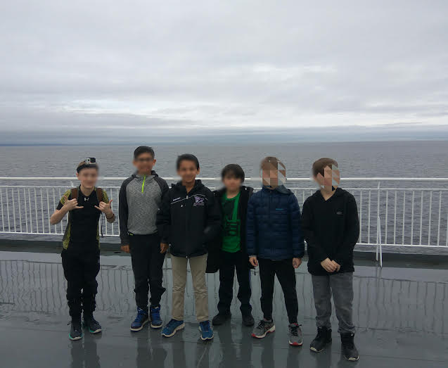
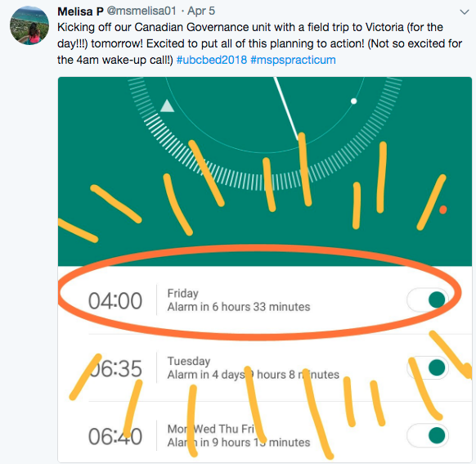
On a cold, rainy morning, I met my students in front of James Park Elementary school at 6:30 a.m., each student more eager than the next to get on the bus and head to Victoria. The trip to Victoria had been a work in progress since I started my practicum in October at the school. My SA was very good at making it clear what I would be responsible for teaching when I took over full time, and I thought that a trip to the provincial capital would be a perfect launch into Canadian Governance. After calculating the cost of the busses, the ferries and the workshops, the total cost would be about $60.00 per student—a price much higher than many of the families of the students in my class could afford. The money granted to us from the Emily Longworth Award, in conjunction with the fundraising that my 3/4/5s did throughout the year provided us the opportunity to go on a fieldtrip of a lifetime.
First time on a ferry!
The money that was granted from the Emily Longworth Award was used primarily for the booking of the busses (from Port Coquitlam, to Tsawwassan; Pickup from Schwartz bay, to Victoria and then back). Had we not received the money from the award, we would not have been able to afford transit to and from the ferry terminals, and the trip would not have happened!
Trip Overview
When I found out I had to teach Canadian Governance to a group of grade 3/4/5 students, I have to admit that I wasn’t very excited. Government has never been my favourite subject to learn about, and I’m a strong believer that if a teacher is not passionate about a subject, it can often be portrayed that way in lessons. I decided to enter my practicum with a “go big or go home” attitude, pushing myself to teach out of my comfort zone, and plan experiences for my students that they would never forget. As I am new to British Columbia (originally from Ontario; taught for the past six years in South Korea and Singapore), the BC Governance system is new to me, and I decided to take the opportunity to create a “launch” lesson that would really hook the students. After some research, I decided that it would be an excellent idea to take the students to Victoria (for the day!) where we would visit the legislature building, as well as the Royal BC Museum.
A perfect launch to Government!
Learning Outcomes
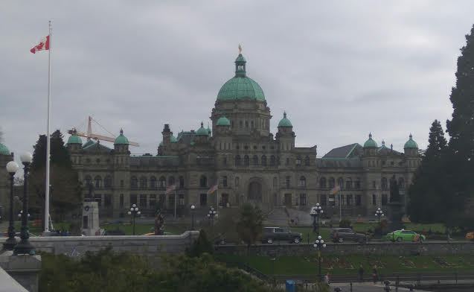
The big idea that the entire field trip was planned around is, “Canadian institutions and government reflect the challenge of our regional diversity,” with the curricular content covering levels of government, their main functions, and sources of funding, as well as participation and representation in Canada’s system of government. By launching the unit with a trip to Victoria, students had the opportunity to get a first-hand experience of provincial government, as well as experience how government worked pre- and post-contact.

The Royal BC Museum
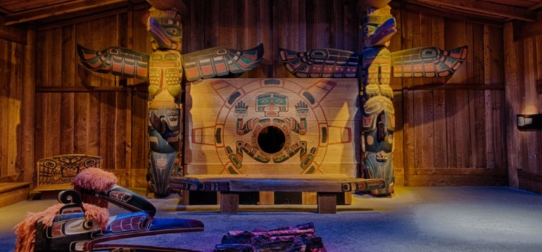
My group of students and I started our trip at the Royal BC museum, where we had the opportunity to participate in a workshop that led out through a series of interactive experiences that introduced concepts of government. The workshop started with a graffiti wall, where students were asked to simply tell one another what they knew about government. Together, we had a wonderful introductory discussion about what government is, and why it is important. Upon completing the discussion, students broke into smaller groups, learning about how governing systems in Canada differed pre- and post-contact. Students had the opportunity to participate in decision-making activities, and de-brief in which structures they preferred. This workshop was an excellent opportunity for students to truly experience what government is, and how different it was before colonialism. This also stimulated thinking amongst all students, inquiring why we think of government in only a post-colonial context. These questions that students asked were written down, and we continued exploring them throughout the entire unit. By participating in this workshop, students were able to see (and experience) the different types of government that have existed in Canada.
The Long House at the Royal BC Museum: Students participated in a pre-contact governance system to get them thinking about governing before Canadian government.

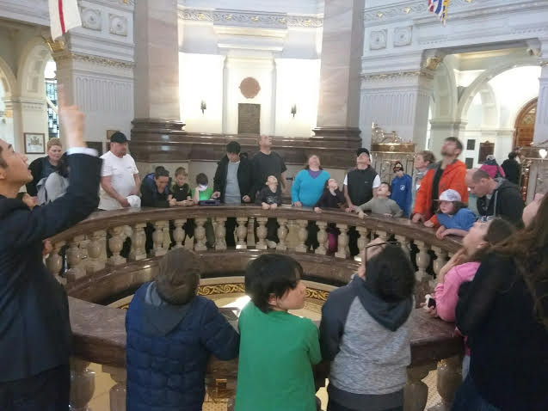
The Provincial Legislature
Upon completing our workshop at the Royal BC Museum, we walked over to the Provincial Legislature, where we were given a tour of the Legislature building. This tour allowed my students to experience what provincial government is first-hand, all of my students excited to be in a place where the laws are made. Throughout the tour, I had students inquiring about how people got to work in the building, what kinds of laws were made in the building, and why we have to have a provincial government system. All of the questions that students asked me served as guidelines to my entire unit of study. While on our tour of the building, we also had the opportunity to participate in a debate, an activity that my students were extremely excited about. With the initial question, “should parents pay their children for chores?” I had all of my students take a stance had have a legitimate debate. This debate served as a perfect comparison of how debates occur in the Legislature, allowing my students to make connections of government, to real life.
At the Provincial Legislative Building 1
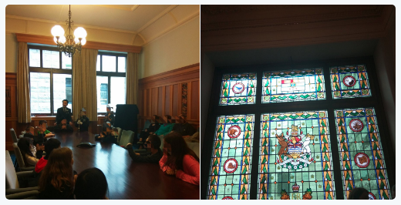
Students participating in a debate and learning about the BC Coat of Arms
For the rest of the day, my students were divided into groups and had the opportunity to explore the city with parent chaperones. Students were encouraged to take pictures, write down the names of streets and buildings they had questions about, as well as document anything interesting they saw. While transporting back to the ferry terminal, I had so many of my students asking questions, eager to know more about governing systems.

Conclusion
The money granted by the Emily Longworth fund truly changed the way my students learnt about government. A topic that is often dry and boring was transformed into an experience where students were immersed in government, and “hooked.” For the following ten weeks of teaching this social studies unit to my class, my students were truly interested in what they were learning, connecting nearly everything to the trip. Whether it was discussing law making, voting rights, heads of government or human rights, students were all able to make connections to what they had experience in Victoria. A HUGE THANK YOU!

