**Emily Longworth Memorial Award: Lynn Canyon Ecology Center**

On Tuesday, April 17th, my school advisor and I took our grade two class of eighteen students to Lynn Canyon Ecology Centre. I had originally planned for a field trip to Capilano Suspension Bridge, but unfortunately, the park was not offering the programs due to park maintenance and repairs. I found a similar program at Lynn Canyon, which is a short drive from Capilano Suspension Bridge, and therefore, a comparable bus cost. Because this project was partially funded, the Lynn Canyon Once Upon a Tree Program also offered a more affordable alternative to the original project proposed.

The money from the Emily Longworth Memorial Award is greatly appreciated as the cost to travel to the park alone would have surpassed a reasonable amount to ask for the students to pay. Most of the students in the class are not offered many experiences outside of the Delta/Surrey area, and therefore, this trip would not have otherwise been experienced by a majority of these students outside of school time.

Upon arriving at Lynn Canyon, we had a brief lesson in the ecology center about the temperate rainforest, which reviewed many of the concepts we discussed leading up to the field trip. We divided the students into two groups to hike on different paths in the park, but they all participated in the same activities within their groups. The first activity was Seed Survival, which involved each student receiving a card that had an environmental condition on it, such as *no water*. The instructor pointed out three trees that students could choose to run to when she made a bird call, but the rule was that at least three students had to be at each tree. After making the bird call, the students at each tree had to look at their cards collectively, and determine whether the conditions were optimal or poor for a seed to grow. After playing a few rounds of Seed Survival, both groups started on a hike through the rainforest.



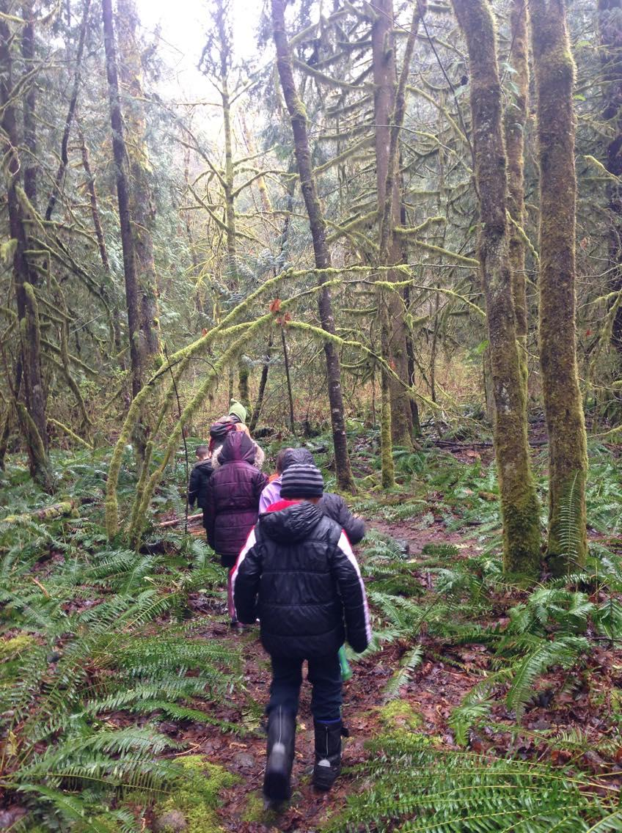

Once we were in the rainforest, each student made a perfume using various plants and flowers that they found. Much of the trip was inquiry-based, as most of the learning was driven by the students’ questions and curiosities. For instance, they were given time to explore the rainforest to collect plants and insects that we would later take a closer look at under a microscope in the ecology center. One student found a type of fungi and another student found a Banana Slug, which the instructor used as talking points. Because it had rained in the morning, we also found many worms during our walk.

However, the highlight of our trip for the students was walking across the suspension bridge. A few students had been nervous about walking across the bridge because of its height from the ground and its wobbliness, but in the end, everyone took the opportunity to stand on the suspension bridge and see the view of the waterfall and Lynn Creek.

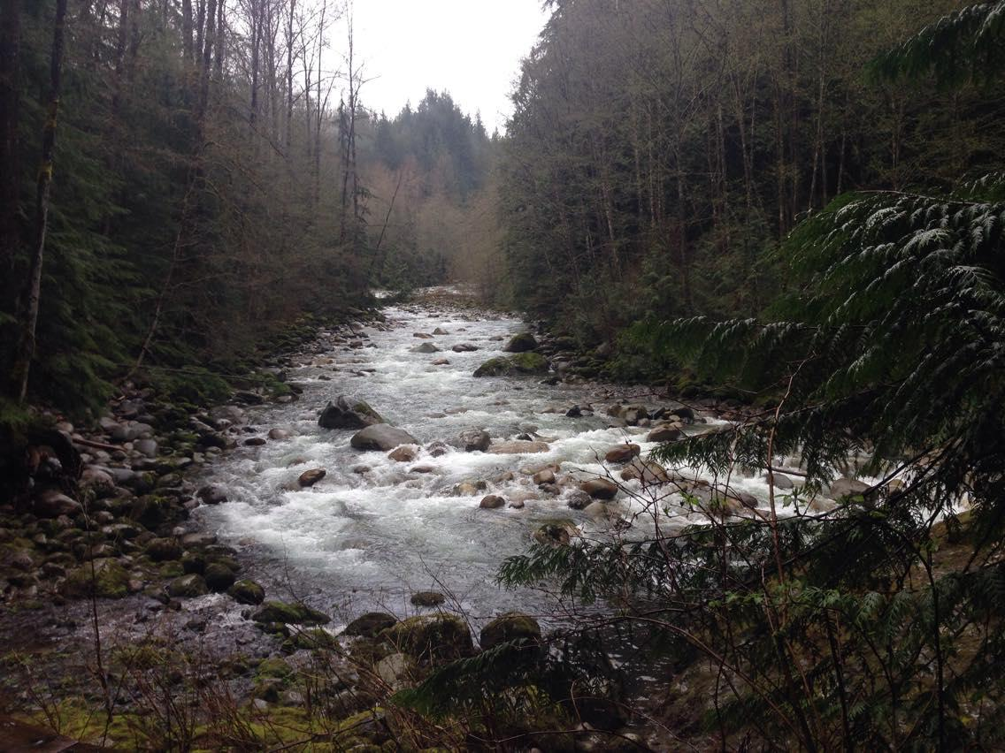

Overall, we had a wonderful time exploring a natural environment, which connected with our field trip to Watershed Park in North Delta and with our units on life cycles, water cycles, and environmental stewardship. Specifically, the following learning outcomes were addressed:

**Big Ideas:**

* Water is essential to all living things, and it cycles through the environment.
* Living things have life cycles adapted to their environment.
* Canada is made up of many diverse regions and communities.

**Curricular Competencies:**

* Make, record, and compare observations
* Demonstrate curiosity and a sense of wonder about the world
* Experience and interpret the local environment

**Content:**

* Water sources
* Metamorphic and non-metamorphic life cycles of different organisms
* Diverse features of the environment in other parts of Canada and the world

The money given from this award was used in its entirety to cover the cost of the program and a portion of the bus cost. Class field trip funds given by the PAC contributed approximately forty dollars, and the students were asked to bring in twelve dollars each to pay for the remaining amount. The money from this grant has been greatly appreciated, as I had many students after the trip ask if we can go to Lynn Canyon for every field trip. Therefore, we have the utmost gratitude to the Longworth family and UBC for making this learning experience possible for these grade two students.

**Final Budget:**

Bus Cost: $477.75

Lynn Canyon Once Upon a Tree Program Cost: $131.00

Total Field Trip Cost: **$608.75**

Money received from Emily Longworth Memorial Award: $352.00

Money from PAC: $40.75

Student Contribution: $12.00 each (18 students)

Money leftover: $0.00