Emily Longworth Memorial Award Report Spring, 2018
For my long practicum I worked alongside my School Associate and Administration at École Maillard to plan a voyager canoe class with Ridge Wilderness Adventures. We planned to spend a day in May paddling, hiking and learning on Pitt Lake and up Widgeon Creek.
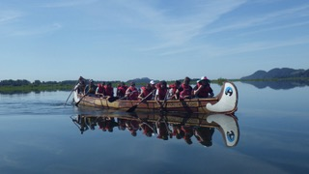
We planned for our trip by preparing course work and projects around the following curricular competencies and content from the Grade Seven Social Studies curriculum:
- assess the significance of people, places, events, or developments at particular times and places (significance)
- human responses to particular geographic challenges and opportunities, including climates, landforms, and natural resources
- origins, core beliefs, narratives, practices, and influences of religions, including at least one indigenous to the Americas
We did this through an early man clan PBL assignment that was run by my School Associate in the weeks prior to my long practicum and an Ancient Civilization inquiry project run by myself.
On May 14th my class loaded into a bus and drove to Pitt Lake, the world’s second largest tidal lake, and met up with out guides: Jon, Susan, Thomas, and Ethan. All four were amazing and engaged and informed and friendly and everything I would want from outdoor education leaders. There was some concerns within the class about getting into canoes (two voyageur canoes – 26 people can go in each), but these leaders, through ceremonies and routine and narratives, got each of these decidedly land-bound grade 7s and 8s into the canoes with a sense of safety and comfortableness. This was going to be a great day! Many of my students had never been in a boat, much less a canoe heading into the wilderness.
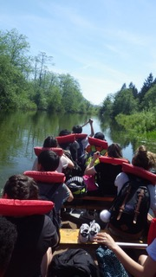
We proceeded to paddle across the southern end of Pitt Lake (through a fairly fast moving current) and up the placid and beautiful Widgeon Creek. As we did this our group leaders began sharing fascinating, poignant, and relevant narratives about the land, its history, its people and various respectful cultural practices when travelling on a through unceded Indigenous territories. In particular we learned that Widgeon Creek is part of the Katzie Nation's history, both past and present, and that many of the First People’s Principles of Learning can be explored through an intellectually thoughtful, culturally sensitive, and physically active but casual way.
After paddling up Widgeon creek for about an hour, exploring various voyageur canoe practices, ceremonies, and history, we arrived at a sandy beachfront under the shadow of a mountain, and began a beautiful hike to our lunch spot two kilometers further up a tributary coming down the mountain side. Along the hike our guides continued to pepper our students with engaging and thought-provoking information and narratives. We spent an hour eating and exploring within sightlines from a shaded grove beside the brook. For many of the students this was a really unique opportunity to explore, in safety, a ‘wild’ space within the lower mainland.
After lunch we retraced our path into the wilderness. Our leaders backed off on the ‘presenting’ per se, but instead gave students to engage in the hike and paddle in whatever way they choose to. Some discussed the stories they had heard, some just enjoyed each other’s company. This half of the trip was also very enjoyable.
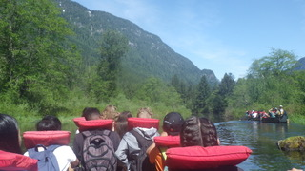
Finally we arrived back at the dock by the bus feeling tired (very tired in fact: so much sleeping on the way home!), but also feeling like we had accomplished something significant, learned a lot, and had an experience that was unique, valid, and a keystone for further community growth.
All in all, thank-you so much for supporting our class in being able to make this trip happen. I hope the administrators of the Emily Longworth Memorial bursary will be able to continue to do this important work.

Nathan Kok UBC Teacher Candidate 2017 / 2018

