Student Impact Story: Nataliia Kudryk
Manoah Steves Elementary
Project: Britannia Mine Museum
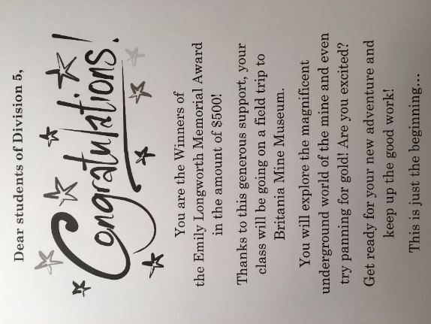
Earlier in the year of 2018, I found out that my proposal was successful and that I would be able to take my practicum class to the Britannia Mine Museum. I was very excited about this amazing opportunity and wanted to present this information in a creative way to my students. I typed a letter explaining the exciting news and put it in a small envelope under one of my students’ desks. When they got into the classroom after recess, I started a quest around the classroom in which they had to find the envelope! The “treasure hunt” definitely sparked my students’ interest and when they found the envelope and learned about the news, they were beyond thrilled and excited that they would be going to the Britannia Mine and even try panning for gold!
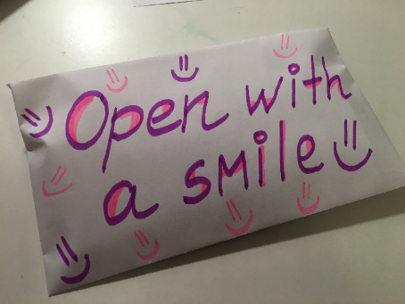
We started our field trip early in the morning and went on a picturesque road trip to the Britannia Mine. It was a long ride (about 1,5 hour from Steveston, BC), but it was so worth it! The views from the windows were breathtaking and everyone was in awe.
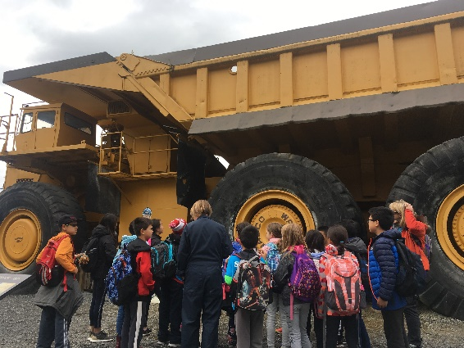
Once we got to the mine, the tour guide started our learning journey by teaching us about different minerals and rocks. Since my students have been studying about mining earlier in the year, they had some background knowledge and could contribute to the conversation. We were invited to visit the mine’s museum and explore a huge collection of rocks and minerals they had in display! It was very interesting for my students to learn about different properties of minerals and rocks, their characteristics, as well as being able to look at them through a microscope! The session was very informative and engaging.
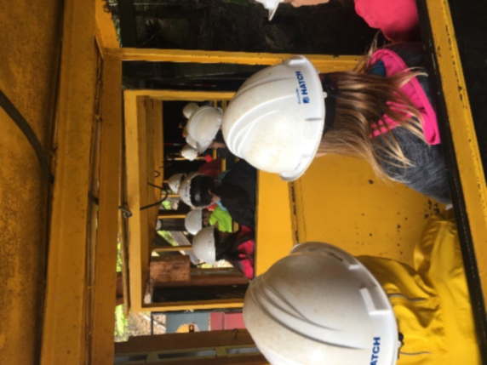
Next, we had our lunch and students got to play outside for some time. It was a perfect time to stretch our legs after a long road trip. After that, we put our helmets on and went to explore the magnificent underground world of the mine! The train ride was very intriguing and exciting. The train made a couple of stops and the tour guide showed us some of the machinery that people used in the past and different inventions that made work easy for them! We all found out that mining is one of the hardest and most dangerous jobs in the world.
After the tour in the mine, we went to see the rock collection museum that had thousands of rocks in it! And then we were lucky to explore an old mill that had a 700ish step staircase. Lots of movies were shot in it and the place itself surprised us all by its massiveness.
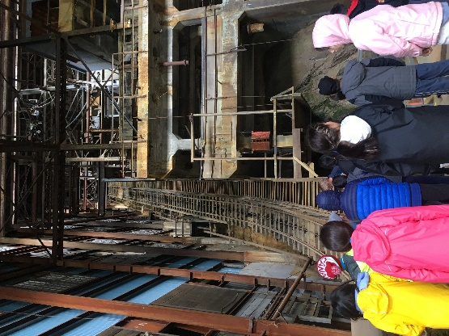
Followed by all of these events, there was something that everyone was looking forward to since January – the gold panning! Students were told that all the gold they found, they could bring home. It was a pure happiness and joy! The kids were busy panning for gold and time flew by so fast! Not only they found some gold, but also many gems and colourful rocks that they brought home as a souvenir from our field-trip.
We were all impressed by all we saw and learned during our field trip to the Britannia Mine! We went back to Steveston full of impressions, great memories and new knowledge! It was an amazing learning opportunity for all and the best field trip we have ever gone on. All the students of my practicum class and their parents are very grateful for your generous financial support. As a thank you gift, students have put together a small booklet for the Emily Longworth Fund that has their reflections on the field trip that I am sure they will never forget.
Thank you so much to the Emily Longworth Fund for helping make my students’ dreams come true!
