STUDENT IMPACT STORY: Miguel Gomez and Amanda Griffin

Captain James Cook Elementary School

Project: The Bloedel Conservatory and Queen Elizabeth Park

Thanks to the Emily Longworth Memorial Award, ​we were able to take two primary classes (grade 1 and 3; 42 students) to the Bloedel Conservatory at Queen Elizabeth Park. Our classes are “buddy” classes and do many activities together. With the funds, we were able to pay for a school bus and for the admission costs. Our school is classified as a Tier 3 inner-city school so we were happy to be able to provide our students with a free educational experience that would not cost students anything. The day was both fun and memorable for everyone.

The field trip was also a wonderful way to conclude the units we had been working on in science. The grade 1 class had just finished a unit on plants, so visiting the Bloedel Conservatory was a great opportunity to experience a variety of plants from around the world. The grade 3 class was wrapping up a unit on biodiversity and the relationships between living things in an ecosystem. They had been learning about the interdependent roles of producers, consumers, and decomposers with a particular focus on the flow of energy from one living thing to another. Our visit to the Bloedel Conservatory and Queen Elizabeth Park enabled the students to observe and experience a diverse range of living things that interact in both local and exotic settings.

When we arrived at the Bloedel Conservatory, students gathered in small groups and took part in a self-guided tour with accompanying teachers. Students from both classes were paired up and they completed a scavenger hunt. They had the challenge of looking for different exotic birds and plants around the conservatory. Students really loved seeing all the different kinds of exotic birds and plants. We were so happy to see our students get so excited, especially when some of the birds walked along the pathway. This gave students a unique chance to see the birds up close!

After the Bloedel conservatory tour and a quick snack break, students were led into the large outdoor garden and worked on identifying living and non-living things in nature. In pairs, the “big buddies” in grade 3 helped out their “little buddies” in grade 1 with this task. The grade 3’s were encouraged to use their knowledge of living (and non-living) things to support the students in grade 1.

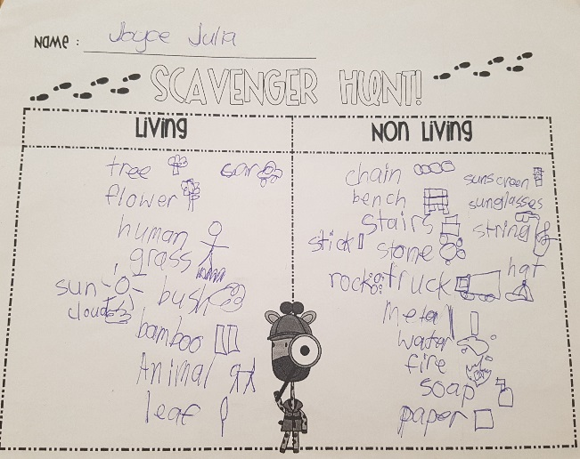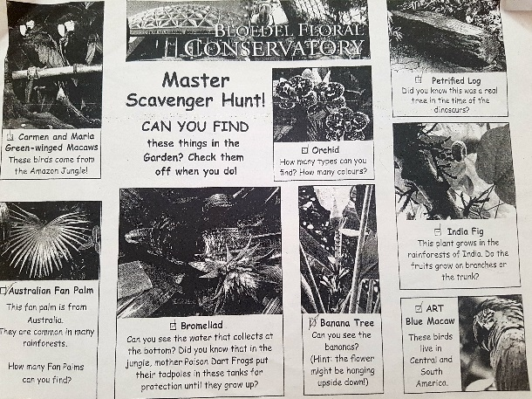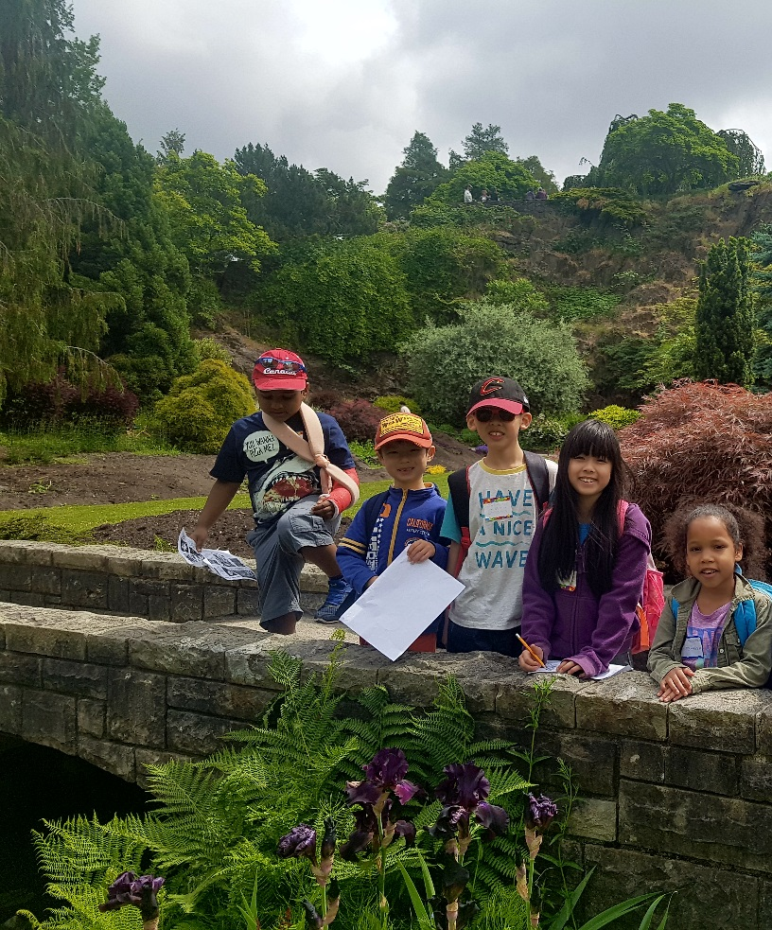

Following the activities, we had lunch in a large field below the main garden in Queen Elizabeth Park. Students played in a large open green space. They were able to run around, playing games like tag and frisbee. It was also a wonderful opportunity to enjoy the wonderfully sunny weather and take in a bit of what the local environment had to offer. The open green space was surrounded by all sorts of plants, and ducks swam in a nearby pond. After the field trip, the grade 1 students enjoyed making a comic strip reflecting on their favourite parts of the field trip.

Overall, our trip to the Bloedel Conservatory and Queen Elizabeth Park was a wonderful experience made possible by the Emily Longworth award. The support we received was much appreciated, and it gave our classes an opportunity that may otherwise not have been possible.