Student Impact Story: Sarah Nafrey
James Whiteside Elementary School, Richmond B.C.

Project: Medicinal Tea Garden

I fell in love with land-based learning while volunteering with grade 3 students as part of the Intergenerational Landed Learning Project at the UBC Farm in the year preceding my entry into the teaching program at UBC and was excited to engage in this type of learning with students during my practicum. A defining experience of my practicum therefore became the transdisciplinary garden unit of inquiry my students and I explored together. This richness of this unit truly was made possible by the funds generously provided by the Emily Longworth New Teachers’ Creative Activity Fund, allowing our learning to come alive in authentic, meaningful, and memorable ways.

The seventeen grades two and three students in my practicum class and I created a medicinal tea garden of indigenous plants together, while uncovering the curriculum and discovering how plants can connect us to where we live and contribute to our wellbeing. The garden became a window into increasing our indigenous knowledge, demonstrating the curricular core competencies, and understanding the real-world applications of our learning.
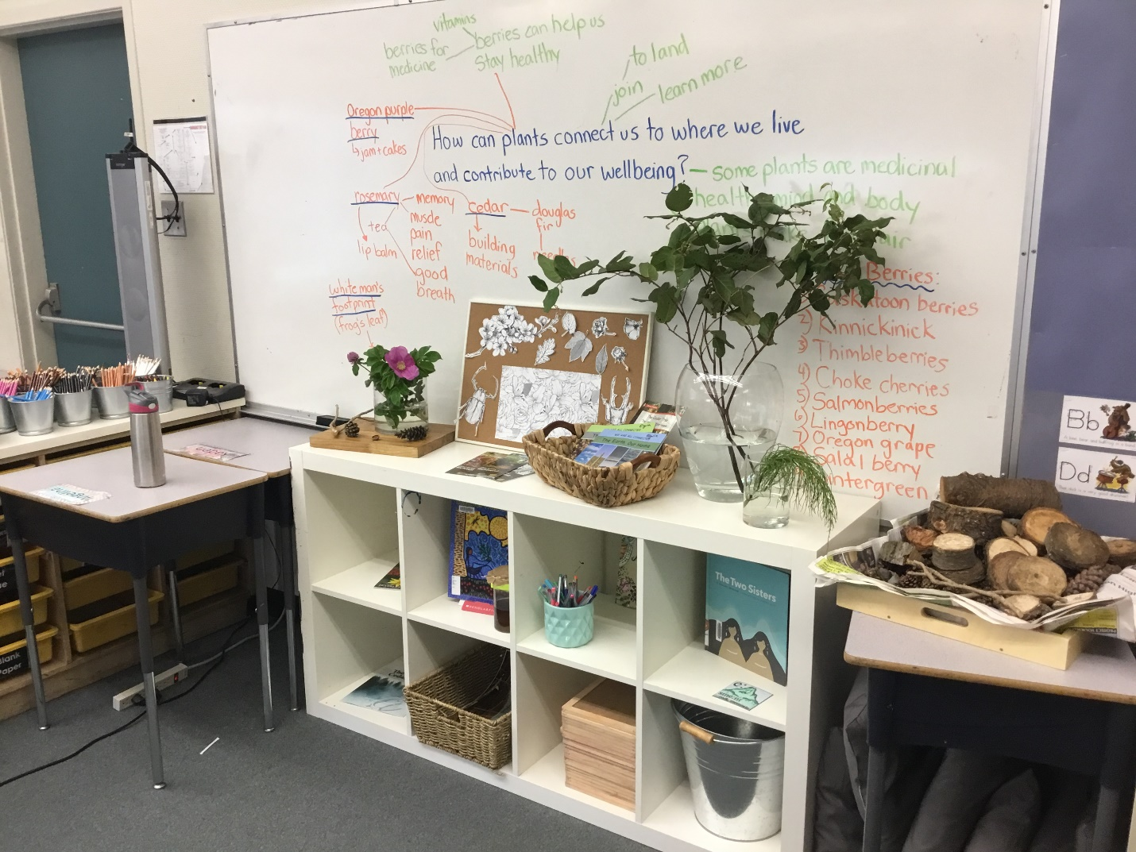

Through this trans-disciplinary unit of inquiry, we explored Science, Social Studies, Math, English Language Arts, Arts Education, and Applied Design Skills and Technology. Throughout our learning, the ideas of sustainability, connectedness, cultural perspectives, and shared human experiences were highlighted. I sought to provide new and captivating learning experiences, cultivating in the students the tools to be capable, lifelong learners and caring global citizens who consider the positive and negative impacts of their choices.

We explored what students were wondering during their learning, worked with provocations, and celebrated together when students shared how they “took action” and were able to demonstrate how their learning changed their thinking. We were able to put our learning into practice and see real-world applications of it. The unit was rooted in hands-on learning experiences and allowed for students with diverse interests to come together to focus and learn through a central idea but with room to make the learning their own by following their own interests through the process. They made numerous connections to their families, cultures, and countries of origin during our learning, which made the experience richer for everyone.

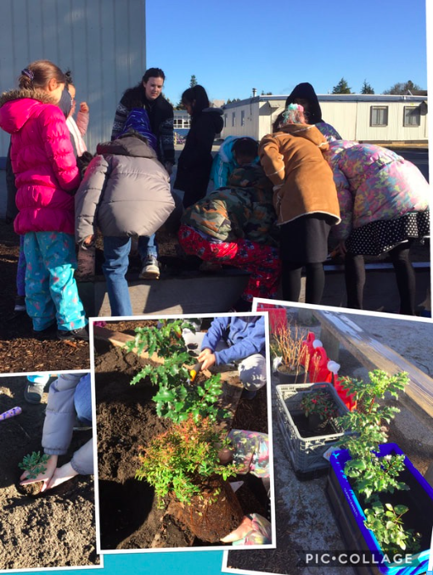
Our experiences in the garden began with a day of planting. We cleaned out our bed in the school garden and planted nine varieties of berries indigenous to British Columbia, including salmonberries, salal berries, choke cherries, kinnikinnick, and many more. We also installed a rain gauge and thermometer in the garden. We then planted 8 additional varieties of indigenous plants in the indoor garden that we created in our classroom. In the following weeks, we learned how to care for our plants and researched their traditional uses by First Peoples in British Columbia, connecting to our place, and focusing primarily on the medicinal uses of each plant and how they were used respectfully and sustainably and continue to be used today. The students were surprised to learn that not only were all the plants we were growing medicinal, but that each part of many of our plants had multiple medicinal and other uses. The students became ethnobotanists-in-training and very excited to share their knowledge with others.

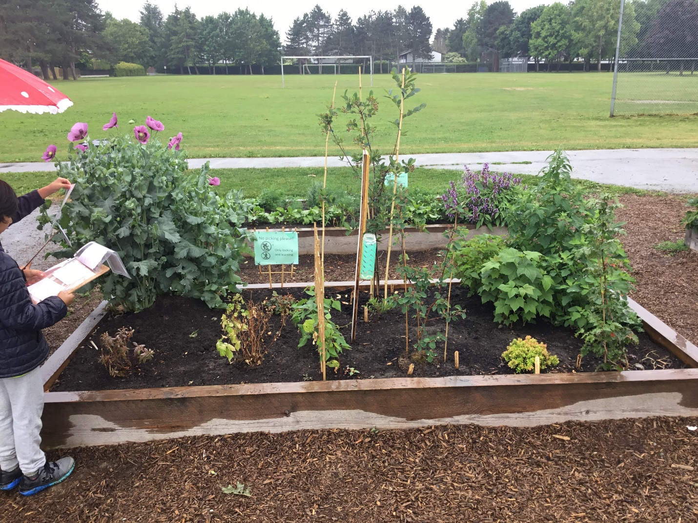
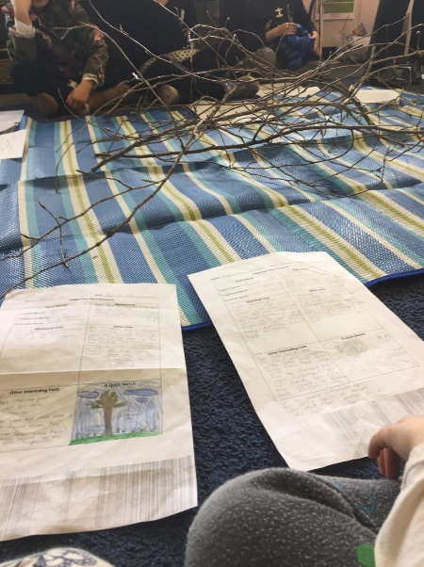
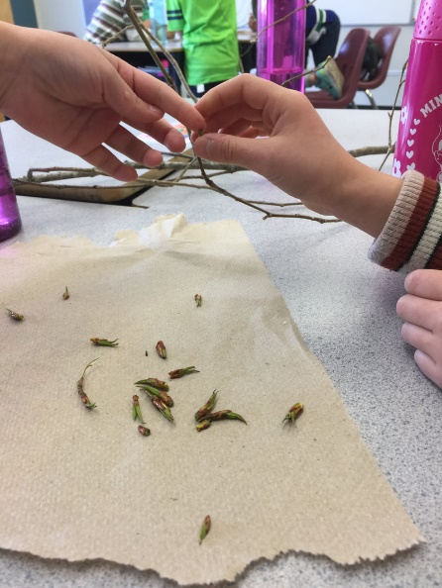
Making medicinal cottonwood oil (photos on left)

The students played enriching games around the garden, worked to deepen their knowledge of plants they were individually interested in, taught one another, investigated and asked thoughtful questions, collected and graphed garden data, wrote about the garden, sketched it, and developed a relationship with this special space.

After a few weeks of learning through the garden, our class visited Richmond Nature Park* to connect to themes from their transdisciplinary, garden-based unit of inquiry, particularly the big ideas within Science and Social Studies. With the help of a very knowledgeable guide at the park, we learned how to identify plants found in the bog that have been traditionally used by First Peoples and about how these plants are harvested and used throughout the seasons. We also learned about how the landscape and ways of life for communities in Richmond have changed throughout the years. Our experience concluded with making twine jewelry from plants and tasting tea and fruit leather made from medicinal plants growing in the bog. The students were very interested in learning more about where they live during the field trip and also proud to be able to share some knowledge they had already built in our school garden with our guide at the park. This excursion helped to solidify learning from the unit for students as they were able to see real-world applications of their learning and connect to their place in a context outside of the school grounds.
*Due to a change in programming at the UBC Indigenous Health Garden, I had to change our field trip location to Richmond Nature Park. The Nature Park was a wonderful alternative and connected very well with the unit.

On the last day of my long practicum we hosted a Celebration of Learning in our classroom. Guests included: parents, other classes in the school, staff, and a district specialist teacher. The students shared their learning with visitors at seven stations: medicinal tea and fruit leather from the garden, cattail weaving, garden graphing, garden tours, inviting guests to try medicinal cottonwood oil and to explore our inquiry wall which tracked our learning from the unit, berry art, and a station which compared the life cycles of salmon and salmonberries, discussing how the two species nurture the survival of one another, exploring indigenous and western scientific perspectives.

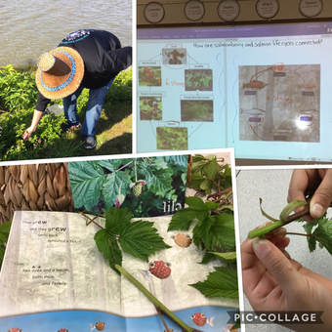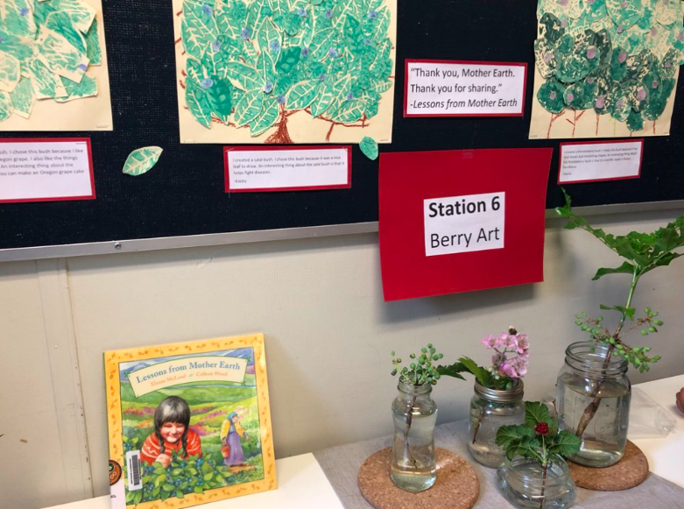
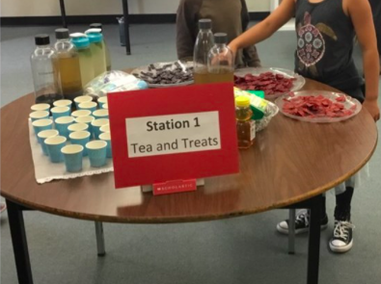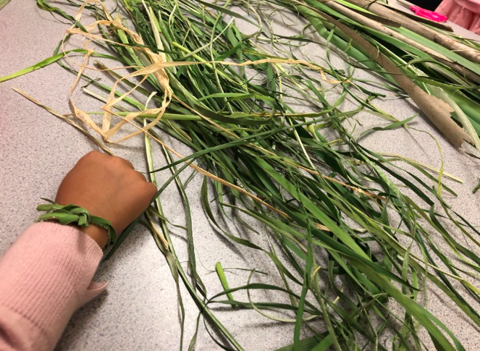
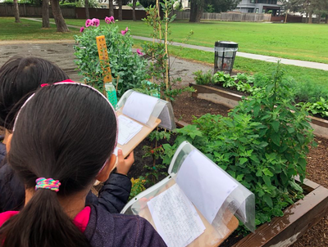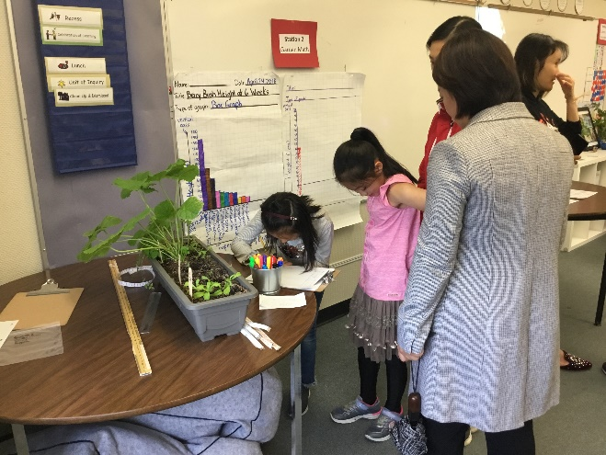

Families and friends were amazed with the learning they witnessed during our Celebration of Learning event and many parents commented that their children had begun to point out indigenous plants in their neighborhoods and to explain their uses. Did you know that rose hips are high in Vitamin C and wonderful in tea? Division 12 does! The students even investigated the health benefits of the dandelions they found growing on the school field, which led to dandelion leaf and mint tea. Who would have guessed that dandelion leaves are great for bone health and that they make a tasty pairing with mint?

The funds we received from the Emily Longworth New Teachers’ Creative Activity Fund were used to purchase: all of the plants, soil, and other gardening supplies, mathematics resources which connected indigenous knowledge and berries to the grade 2 and 3 curriculum, to take the students on their field trip to Richmond Nature Park to explore the indigenous plants they were growing in the school and to discover others, and to purchase supplies to host the Celebration of Learning which concluded our unit of inquiry. These initiatives not only benefitted the students in our classroom, but the entire school community as other teachers were provoked to think about indigenous plants in their community as a learning tool. This unit encompassed authentic Aboriginal perspectives, the First Peoples Principles of Learning, and rich authentic resources.

I would like to extend heartfelt thanks to the Longworth Family and all others involved in the fundraising that makes this valuable program possible.
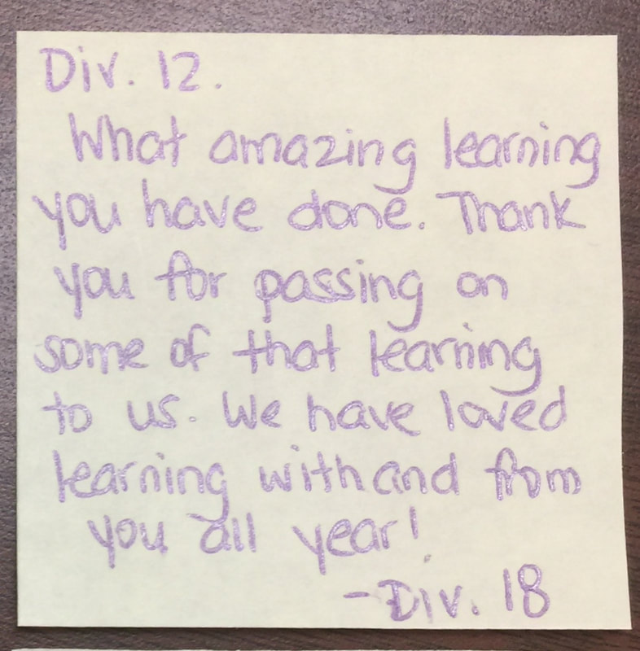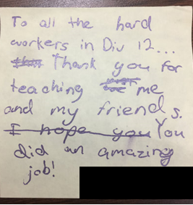
Notes from our Celebration of Learning guests

