Student Impact Story: Sarah Ling
Heath Traditional Elementary School
Project: Fresh Roots

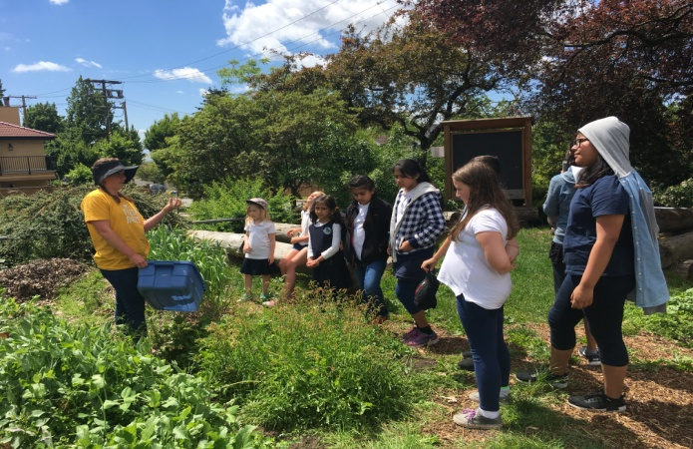

Thanks to the Emily Longworth Memorial Award I was able to take my practicum class (Kindergarten) and their big buddies (grade 4 & 5) on a field trip to Fresh Roots, a community garden in Vancouver. My practicum school was located in North Delta so the students were all very excited to have the opportunity to ride on a school bus all the way to Vancouver. The majority of the Kindergarten students had never been on a school bus before so they were all excited to be able to experience it alongside their big buddies. Thank you so much for the opportunity to plan and experience such a fun field trip.
During my practicum I led an inquiry unit for my Kindergarten students and their big buddies. The inquiry question that the two classes were exploring was “Where does food come from?” At the beginning of the unit we did a mind map together about where food comes from and the students brainstormed the various places that they thought food came from. The list included places such as Walmart, Safeway and Fruiticana. Throughout the unit we explored the many places where we get our food and the students had many more answers when I asked them where food came from at the end of the unit.
The students divided into groups based on their interests and each group explored a different category of food. For instance, there was seafood, processed food, fruits and vegetables, and dairy. Together the two classes researched their particular food group. As well, throughout the unit I led the students in activities that allowed the students to be hands on, for instance, we made sourdough bread together, we made ice cream and we planted various vegetables in mason jars.
Together we learned about the difference between processed and fresh food. The students all became very intrigued with the idea of growing their own food and about farms. They were all very excited to go to Fresh Roots and they all had an amazing time. The field trip began with the students listening to a story that taught the importance of helping out in the preparation of food. They were all very engaged and enjoyed the lesson learned from the story. Next, they had the opportunity to harvest spinach! They all enjoyed this as it was very hands on. After harvesting the spinach they took turns washing the spinach leaves in preparation for their spinach salad. Later, the students had a chance to help weed and dig in the garden. As well, the leaders at Fresh Roots showed us a weed in the garden that was edible. The students enjoyed being able to pick the weed themselves and taste it, it tasted like sour candies so they all loved it! Finally, the students helped create the spinach salad and got to eat it together outside in the sun. It was the perfect day and everyone had such a great time! Thank you again for providing my students with the opportunity to get hands on experience in a garden and deepen their understanding of where food comes from.

