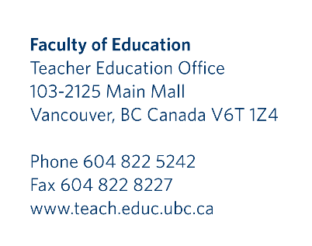

TEACHER EDUCATION PROGRAM FACULTY OF EDUCATION, UBC

I understand that the University of British Columbia in which I undertake my teacher education program is subject to the BC Freedom of Information and Protection of Privacy Act (the “Act”).

I understand that in accordance with the Act, the privacy of students must be protected at all times and that any identifying personal information, including photographs, film, and student work, cannot be used without written permission.

I have provided below my signed consent in accordance with the Act for the University of British Columbia to use or post on the Internet any images (photographic, film or other) and/or samples of my work that may identify myself only for the purpose of enhancing a Faculty of Education cohort website.

I understand that, with the appropriate signed consent, the Faculty of Education may only post identifying images to a cohort website for the purposes of UBC presentation and instructional facilitation.

I provide my written permission below to use identifying personal information, including photographs, film and student work.

Name (please print):
Signature:
Date:

Copies to: Student File in TEO

